For Hospital Management the main concentration is what vaccinations need to be reproduced to get that vaccines with less risk, reduce side effects and get cure for the patients to get that vaccine in time. Because the hospital management just need to know the demand of the medicine based on number of patients need to take the medicine for good health condition. To address the selected audience, my analysis of representing data in tree map. The use of this tree map is to display data in nested rectangles. Each rectangle has different size and color. So, I have considered few columns in the dataset to tell the story to the audience that are concentrated in the hospital managements point of view.

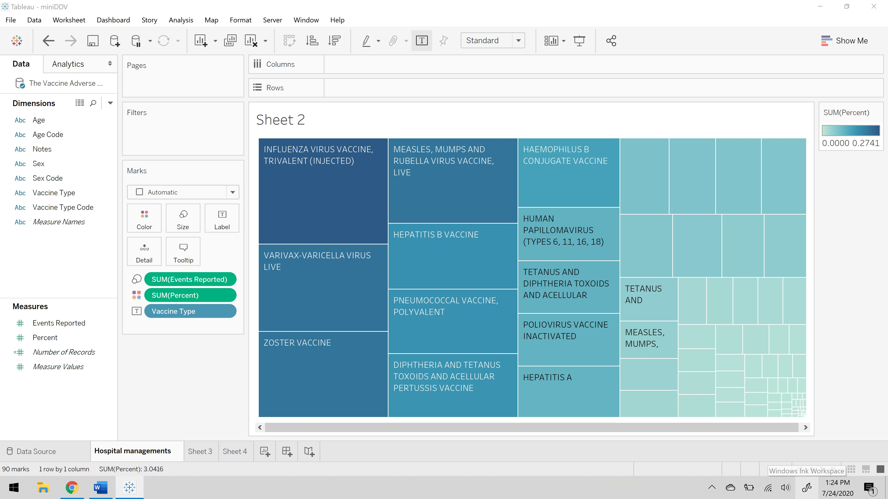

As you can see above visualization vaccines names as been placed on the label as you can see each rectangle is named as you hover on those rectangles. The size of each rectangle is defined by the events reported, which defines the complaints reported by the patients who has taken that vaccines. The color of each rectangle is defined by the percent, which is the risk exposure percentage. So, this visualization states a vaccine should be reconsidered to reduce the risk as per the hospital management’s perspective.

For hospital management, I have considered different visualization cues to understand the story in better way. Let us look at the visualization below and understand it. To do this visualization I have taken vaccine type code on to the columns, next on rows I have considered risk percentage and finally I took count of events reported as the variation of color. This tells us about the vaccine which has recorded highest risk percentage and also the events reported because of taking that particular vaccine.

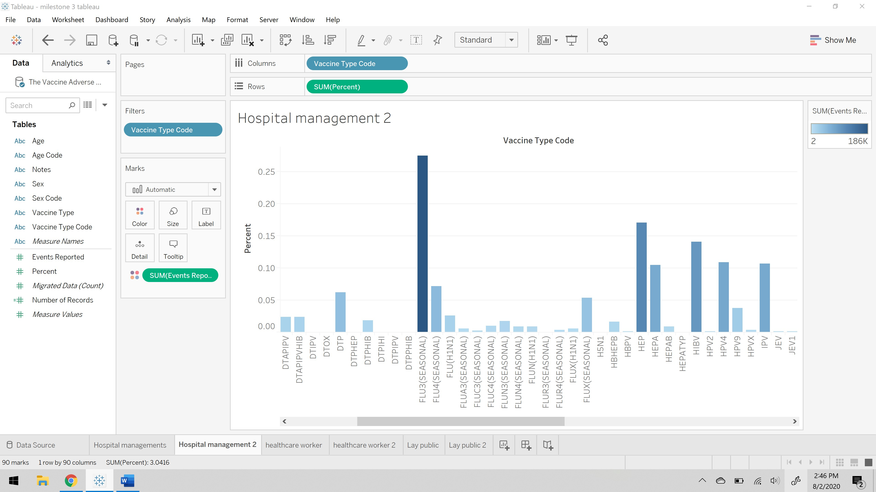

For healthcare workers interacting with families the main concentration of their story is to educate the patient for future side effects and talking through the facts based on the events reported in past. To enhancing the patient condition and preparing them for future as well. To address the selected audience, my analysis of representing data in stacked bars. This is an extended bar chart from looking at numeric values across one categorical variable to two. Each bar in a standard bar chart is divided into a few sub bars stacked on each categorical variable.

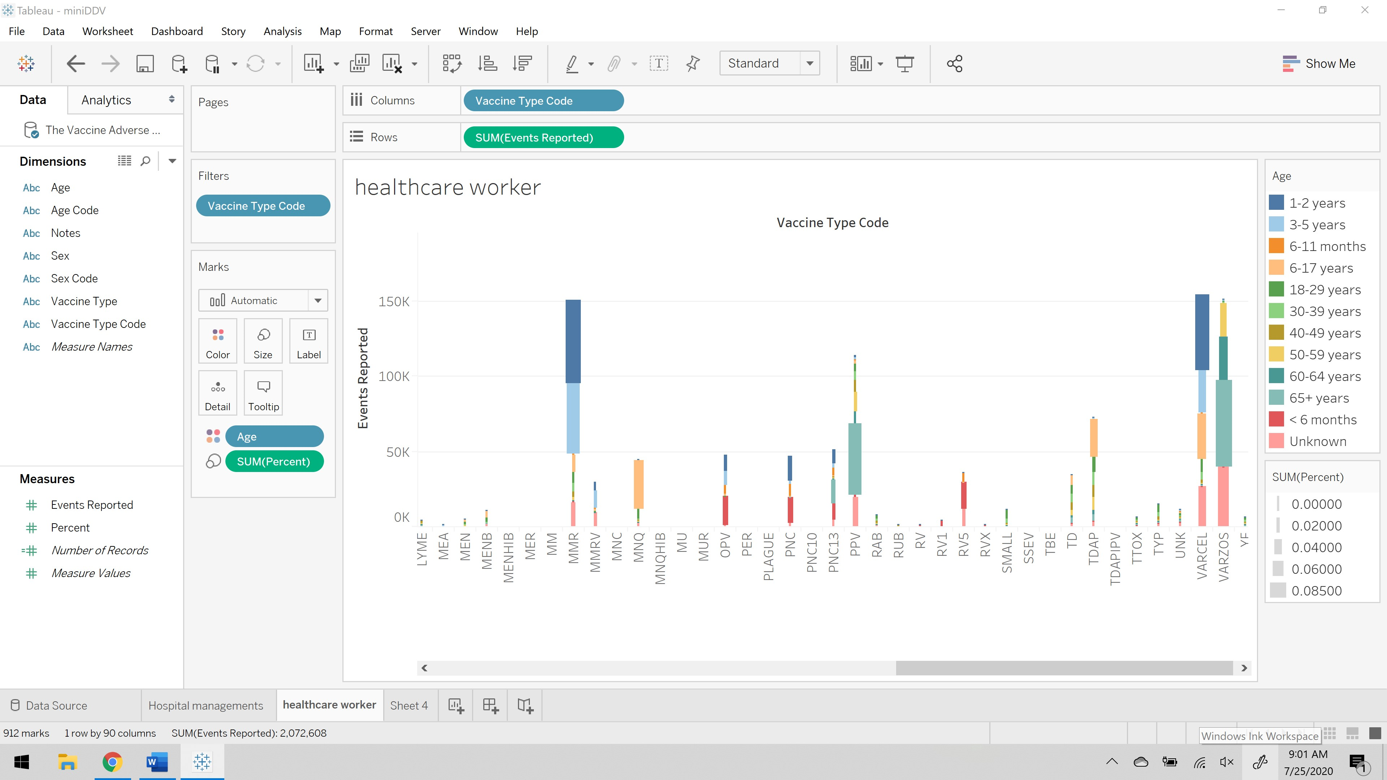

The above representation shows the color difference for age, the size of each bar is based on the risk percent, on x- axis there is vaccine type code and on y- axis there is events reported. This visualization gives us the information of how healthcare workers educate their patients regarding the vaccination and past events reported.

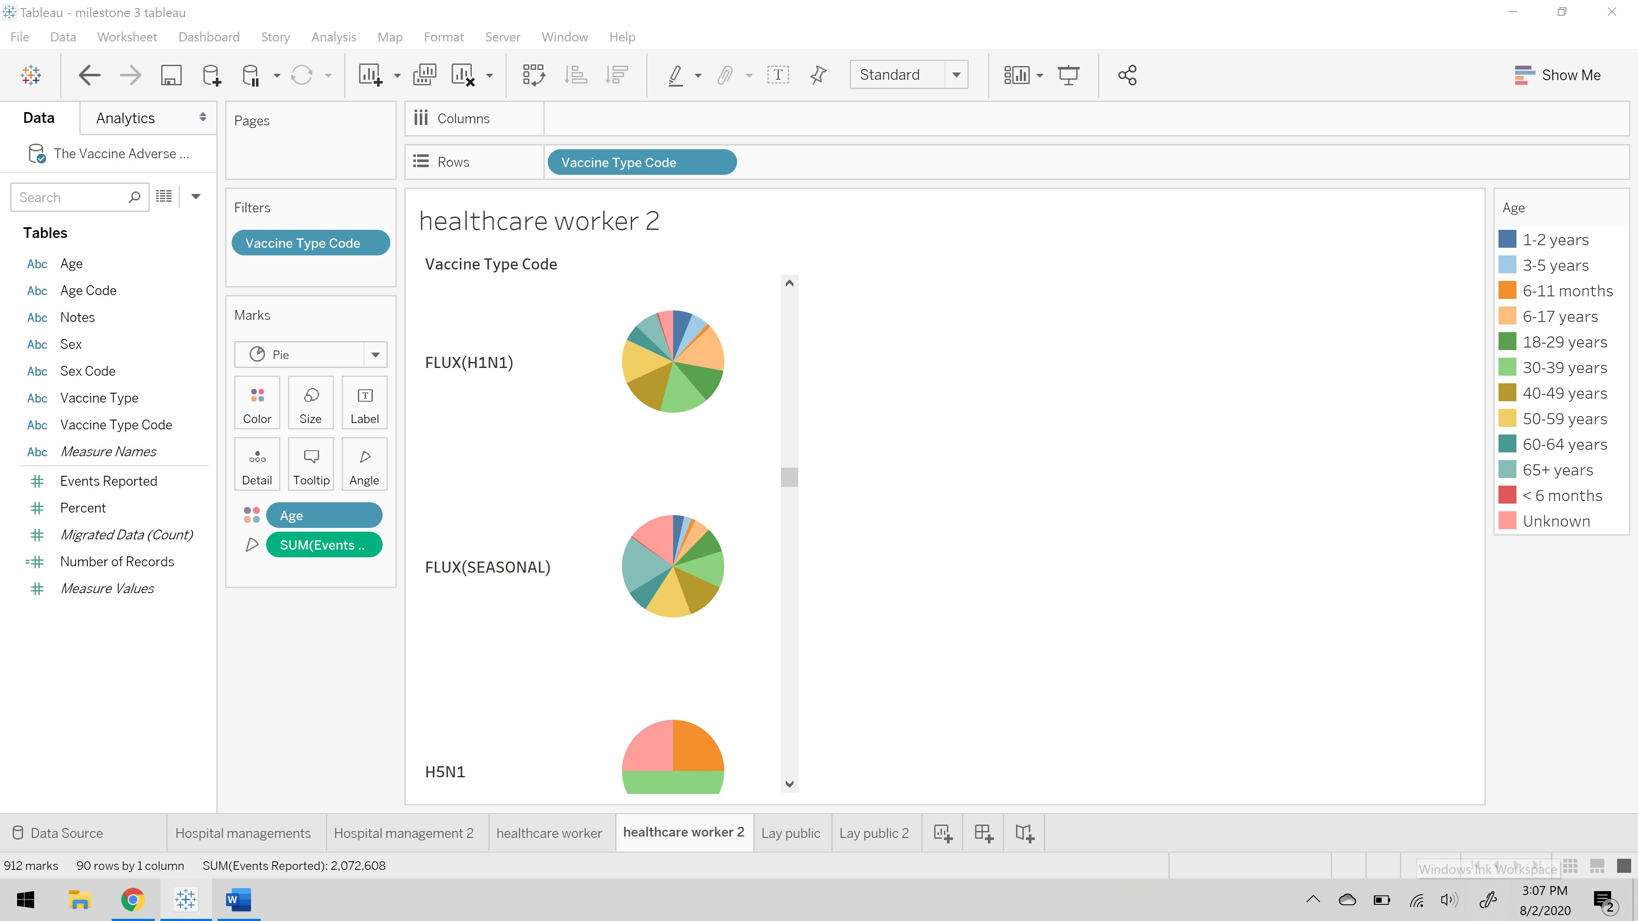

The above visualization is for healthcare workers, this visualization is presented by considering different visual cues and making this story to convey the data in most effective way. So, I have considered pie chart for each vaccine and that pie chart is divided by events reported by the patients and also the color tells us about the count of events reported by that particular age group to get better understanding of the future side effects of the patient at particular age group.

For the lay public audience are to be aware of what vaccination has highest risk percentage. Because the public just need to be aware of the vaccination that are available for the treatments if at all they need to have them what are the consequences. To address the selected audience, my analysis of representing data in Circle View chart. This is one of the powerful visualizations for comparative analysis.

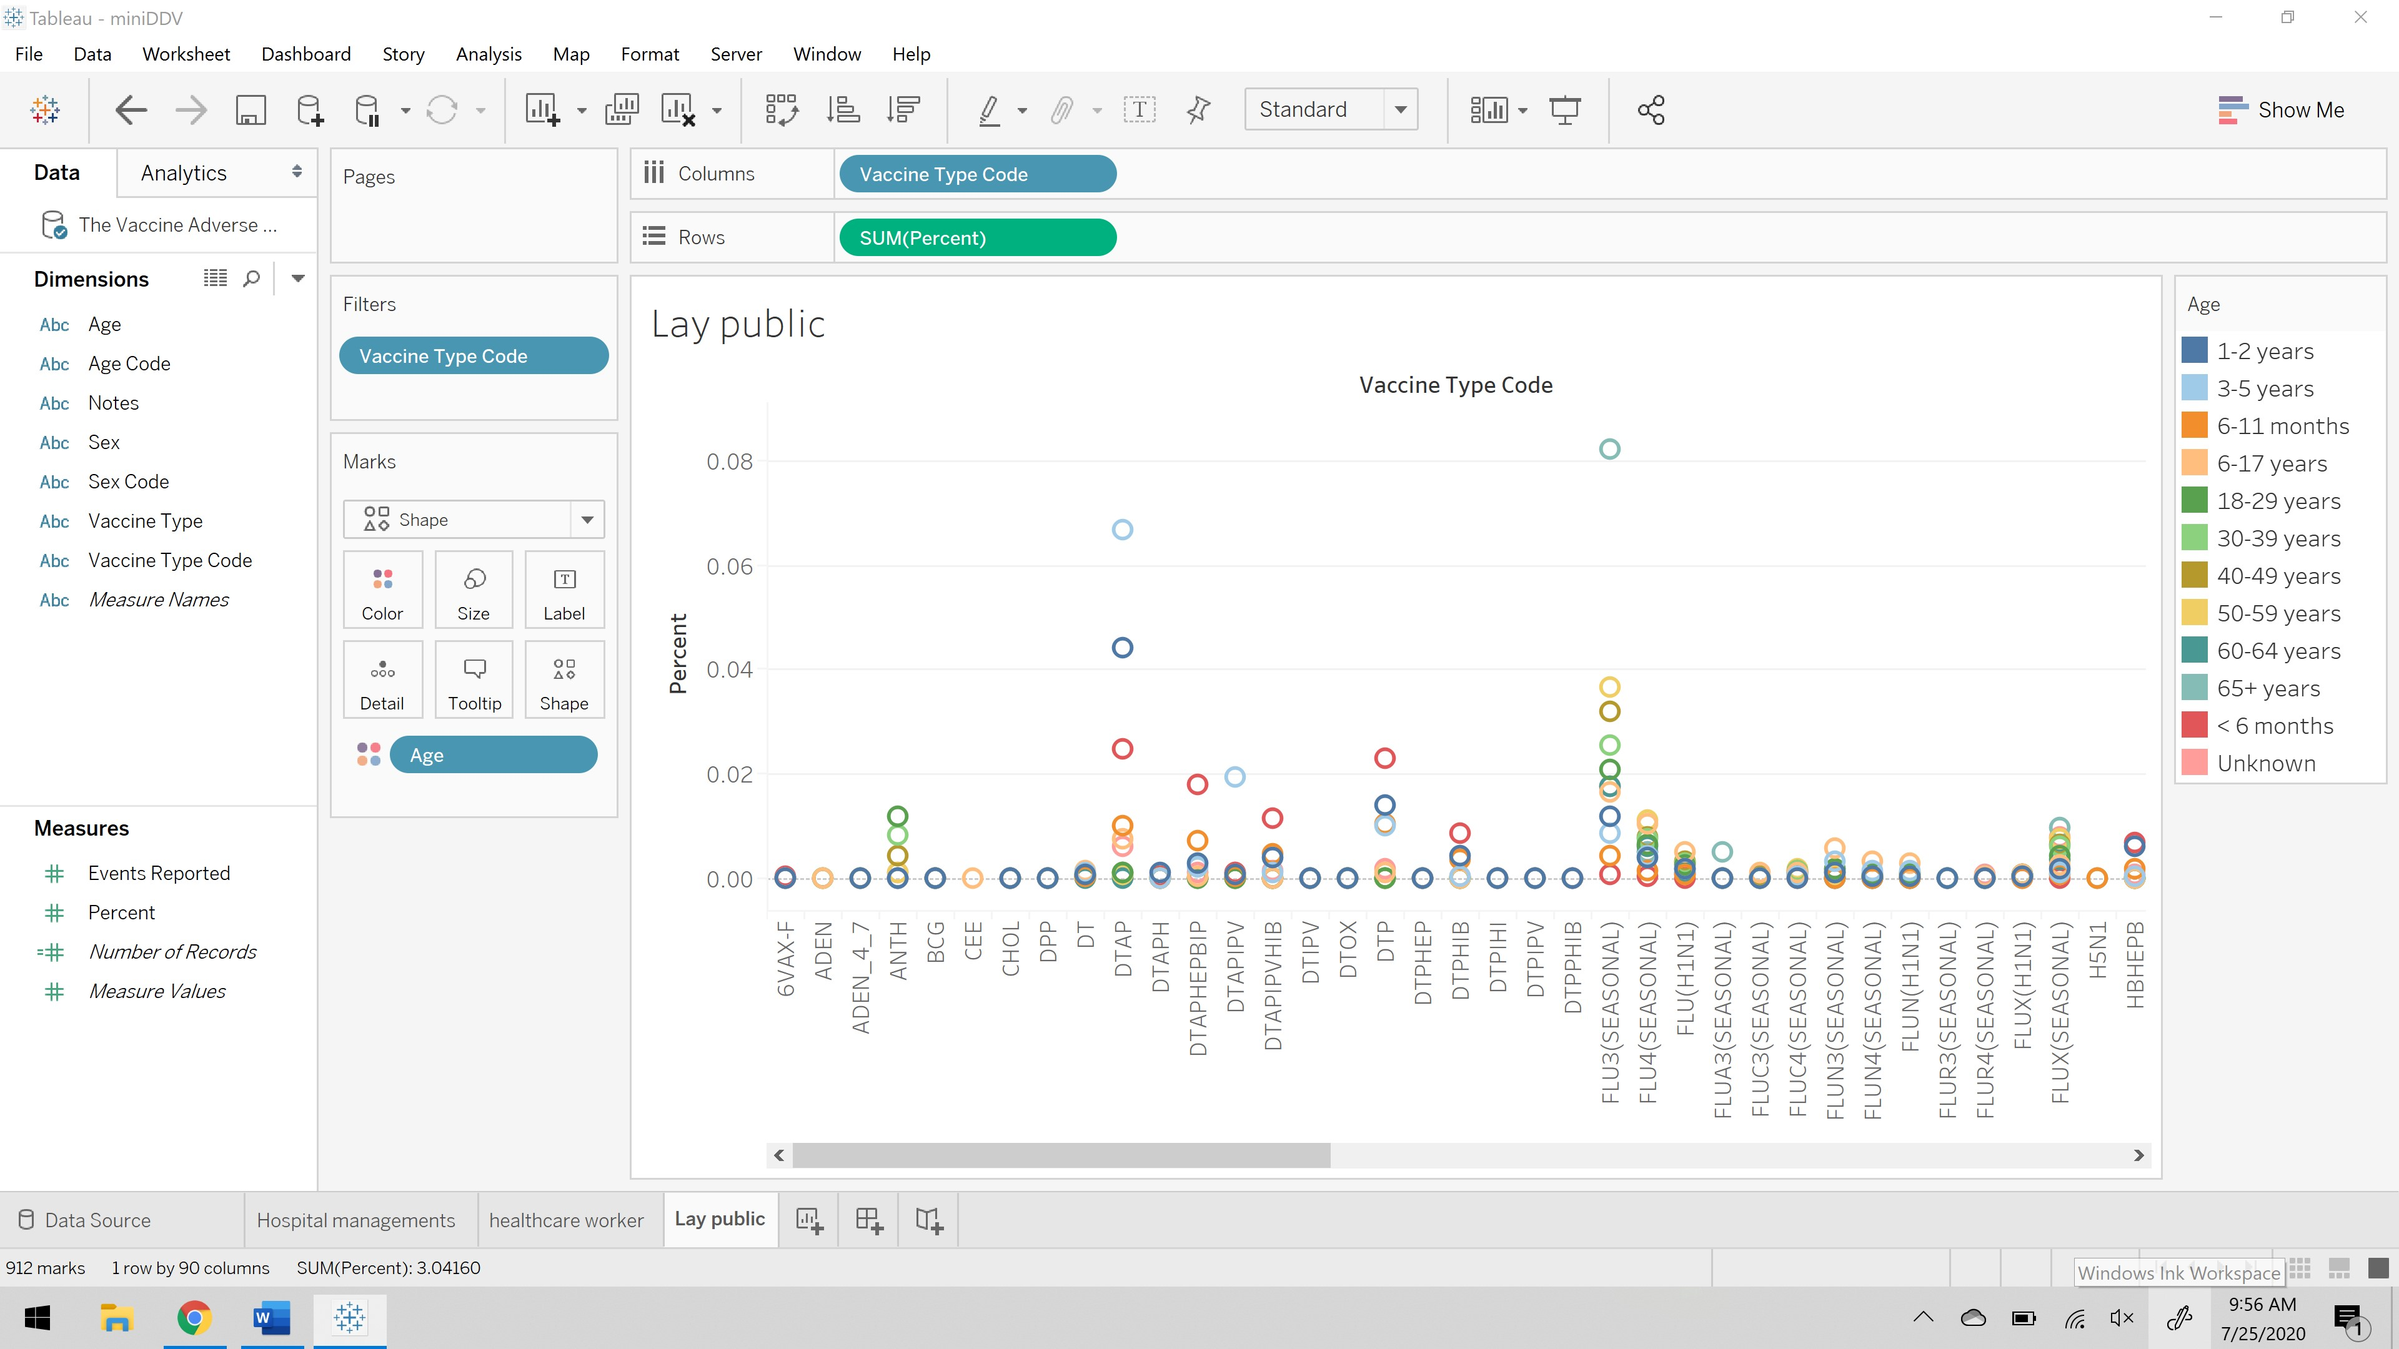

The above visualization shows the variation of color for age range, in x- axis there is list of vaccine type code, and in y- axis there is risk percentage. This visualization helps the public to figure out the what age group has the highest risk in taking that vaccine.

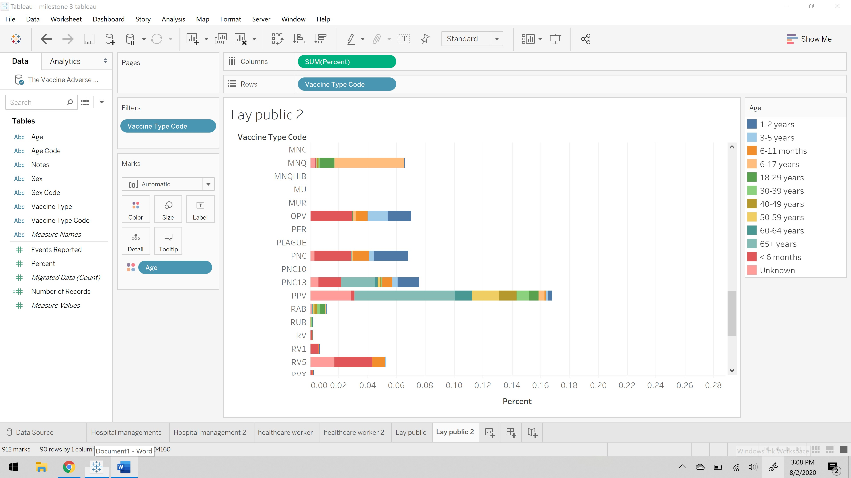

The above representation of the story explains the different approaches of the using visual cues to understand the data in better way possible. I have taken percent and vaccine type code on columns and rows respectively, with the age in color visual cue. This is telling the information about the which vaccine has the highest risk percent and for which age group.

**Order of presentation** I have chosen is initially hospital management’s perspective because total drugs or vaccines information will be received by the hospital management, next comes healthcare workers because doctors will choose what drug is required for certain patient and introduce them with the drug, and then finally come the lay public then public gets to know the drugs or vaccines work and success and risk rate. This is my order of presentation of different audiences.

**Effective Feedback Mechanism:**

A Feedback Loop is the part of a system in which some portion or all the system’s output is used for future operations. Each feedback loop has a minimum of four stages. During stage one, input is created. Next on stage two, input is captured and stored. Later on stage three, input is analyzed and finally in the fourth stage, the insight gained from analysis is used to make decisions.

**References:**

1. <https://searchitchannel.techtarget.com/definition/feedback-loop#:~:text=A%20feedback%20loop%20is%20the,a%20minimum%20of%20four%20stages.>